ImageSource

User Guide

Prepared by:

Kevin Ryans

Paul Vilchez

Contents

1. Welcome 1

2. System Requirements 1

3. Organizing Images 2

Importing Images 2

Removing Images 2

Editing Images 2

Tags 3

Adding, Modifying & Removing Tag Types 4

Applying, Modifying & Removing Tags 5

Searching Images by Tag 6

4. Image Processing 7

Histogram display 7

Resizing Images 7

Converting a region to grayscale 7

# Welcome

ImageSource is a lightweight and simple image library, with a few select image processing features. ImageSource supports a variety of file formats, including BMP, GIF, JPG, PNG and TIFF.

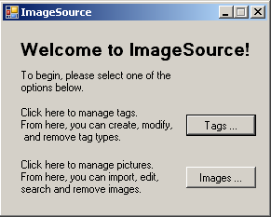

. The ImageSource Start Window

# System Requirements

To run ImageSource, the computer must meet the following minimum requirements:

* Operating System: Windows XP
* .NET 4 Framework

# Installation

For ImageSource to run properly, please ensure that the following files are found in the H:/ImageSource/ folder. If you wish to change this to a different location, you must change the file path in the ImageSource.exe.xml file located in the /bin/debug directory.

* images.xml
* tags.xml
* tagTypes.xml

# Organizing Images

All of the functionality relating to image management and manipulation can be found by clicking on the \\skylab2\ungrad\pvilchez$\My Documents\My Pictures\ImageSource ImagesButton.bmp button in the start window. This will bring up the following window:

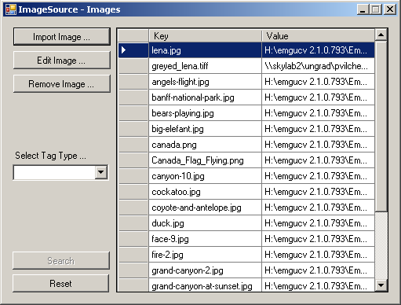

. The Image Library Window

## Importing Images

Click on \\skylab2\ungrad\pvilchez$\My Documents\My Pictures\ImageSource ImportImageButton.bmp and navigate to the picture you wish to import. The picture’s name and file path will appear in the list once it has been added.

## Removing Images

Click on \\skylab2\ungrad\pvilchez$\My Documents\My Pictures\ImageSource RemoveImageButton.bmp. A confirmation dialog will appear; Click Yes to confirm and the image will be removed from the ImageSource library. *Note*: this will not remove the image from your computer.

## Editing Images

Click on \\skylab2\ungrad\pvilchez$\My Documents\My Pictures\ImageSource EditImagebutton.bmpto open the image editor. For more information, please read **Section 4. Image Processing** in this user manual.

## Tags

ImageSource uses two objects: Tag Types and Tags. A TagType is an object that defines the type of the tag by name and by value, whereas a Tag is the value associated with a TagType.

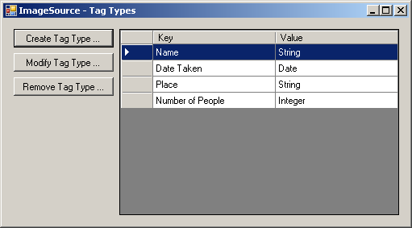

. The ImageSource Tag Types Window

Example:

|  |  |
| --- | --- |
| TagType Key: Name | TagType Value: String |
| Tag Key: Name | Tag Value: “John” |

. TagType vs. Tag

The Tag Key refers to a specific TagType, and the Tag Value is a user-defined input that has to match the TagType Value.

### Adding, Modifying & Removing Tag Types

From the main window, click on \\skylab2\ungrad\pvilchez$\My Documents\My Pictures\ImageSource TagsButton.bmp to open the Tag Types window (as shown in figure 3). From here, the user has the option to add a new Tag Type, modify an existing one, or deleting a selected Tag Type.

**Adding a TagType**

Click on H:\My Documents\My Pictures\ImageSource CreateTagTypeButton.bmp. You will be prompted for the type name, as well as the data type you want associated with it.

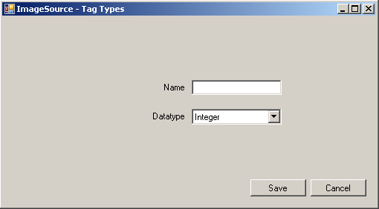

. Creating a TagType

**Modifying a TagType**

Click onH:\My Documents\My Pictures\ImageSource ModifyTagTypeButton.bmp. The prompt in Figure 5 below will appear. The name of the TagType cannot be modified, but the associated data type can.

### \\skylab2\ungrad\pvilchez$\My Documents\My Pictures\ImageSource TagTypes ModifyTagType.bmp

. Modifying a TagType

**Removing a TagType**

Click H:\My Documents\My Pictures\ImageSource RemoveTagTypeButton.bmp, ensuring that the desired TagType is highlighted in the list. After clicking Yes in the confirmation dialog, the TagType will be deleted.

### Applying, Modifying & Removing Tags

Once in the Edit Image window, click on \\skylab2\ungrad\pvilchez$\My Documents\My Pictures\ImageSource TagsButton.bmp in the right sidebar to open the View Image Tags window.

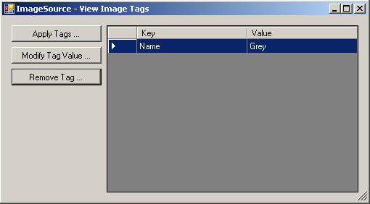

. Viewing Image Tags

This window displays any tags that are currently associated with the loaded picture. In the above example, the picture only has one tag applied to it.

**Applying a tag**

Click on \\skylab2\ungrad\pvilchez$\My Documents\My Pictures\ImageSource ApplyTagsButton.bmp to bring up a control that prompts for a Tag Name and value. Hit Save to confirm and the new tag will appear in the list.

*Note*: for the Date tag, a value of format “YYYY-MM-DD hh:mm:ss TC” is acceptable. A value of format “YYYY-MM-DD” is also acceptable; any other input will not yield proper results.

**Modifying a tag**

Click on \\skylab2\ungrad\pvilchez$\My Documents\My Pictures\ImageSource ModifyTagValueButton.bmp, ensuring that the desired tag is selected in the list. The tag’s name cannot be edited, only the value. Hit Save and the tag will be updated in the list.

*Note*: for the Date tag, a value of format “YYYY-MM-DD hh:mm:ss TC” is acceptable. A value of format “YYYY-MM-DD” is also acceptable; any other input will not yield proper results.

**Removing a tag**

Click on \\skylab2\ungrad\pvilchez$\My Documents\My Pictures\ImageSource RemoveTagButton.bmp, ensuring that the desired tag is selected in the list. Click Yes on the confirmation dialog and the tag will be removed from the list.

### Searching Images by Tag

Once in the Images window, select a tag type using the dropdown menu on the left side. Enter the desired query in the ‘Containing …’ textbox, then hit search. To view all images with a certain tag, leave the textbox blank. To see the entire image library, leave both the dropdown menu and textbox blank.

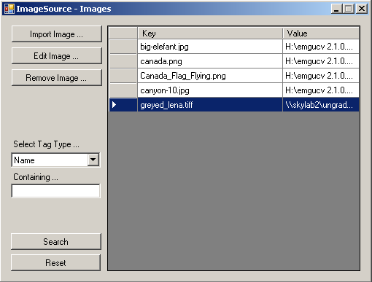

. Searching for all images with a Name tag applied

*Note*: for the Date tag, a query of format “YYYY-MM-DD hh:mm:ss TC” is acceptable. A query of format “YYYY-MM-DD” is also acceptable; any other input will not yield proper results.

Clicking on Reset at any time will clear the search fields and show the entire image library.

# Image Processing

To access the following functionality from the home screen, click on H:\My Documents\My Pictures\ImageSource ImagesButton.bmpthen H:\My Documents\My Pictures\ImageSource EditImagebutton.bmp.

The window in figure 9 will appear.

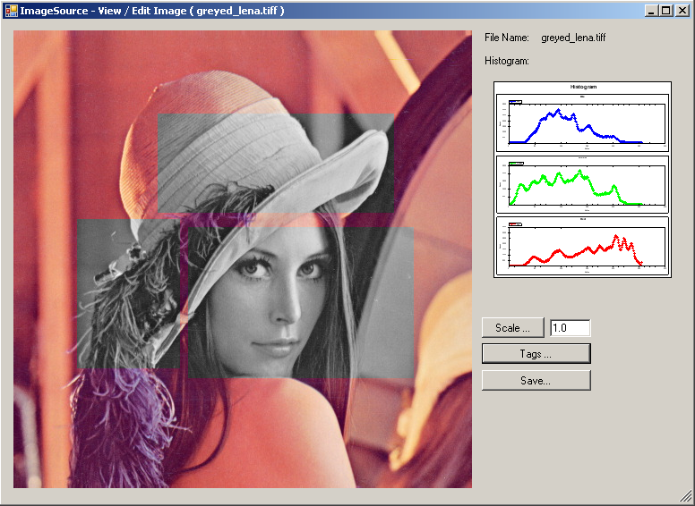

. View/ Edit Image window

## Histogram display

When the image is loaded, a histogram of the image is generated. This histogram, displaying Blue, Green and Red values, is loaded onto the right hand side of the window.

## Resizing Images

To resize an image, enter a value into the textbox beside the ‘Scale’ button. A value of “1.0” represents 100% and similarly, “0.5” represents 50%. All values are relative to the original size of the image, so pressing ‘Scale’ twice with a value of “0.5” will only display the original image at half the size.

## Converting a region to grayscale

Click and drag over any region of the picture to select it as a region of interest. As soon as the mouse button is released, the target area will be converted to grayscale, and the histogram of the picture will be updated accordingly.

## Saving Images

Click \\skylab2\ungrad\pvilchez$\My Documents\My Pictures\ImageSource SaveButton.bmp to open the Save window. If the same filename and path are used, ImageSource will overwrite the original image. Otherwise, ImageSource will save the image using either the new filename, path or both.